NALAIYA THIRAN PROJECT BASED LEARNING ON PROFESSIONAL READLINESS FOR INNOVATION, EMPLOYNMENT AND ENTERPRENEURSHIP

Personal Expense Tracker Application

# A PROJECT REPORT

**MANIKANDAN M (712219205020)**

**JAGADEESHWARAN T (712219205015)**

# MUKILARASAN P (712219205021)

# SUDHAKAR M (712219205038)

# YOKESHKUMAR P (712219205041)

**BACHELOR OF TECHNOLOGY INFORMATION TECHNOLOGY**

# PARK COLLEGE OF ENGINEERING AND TECHNOLOGY,KANIYUR,COIMBATORE-641659

### INDEX

1. **INTRODUCTION**
   1. Project Overview
   2. Purpose

### LITERATURE SURVEY

* 1. Existing problem
  2. References
  3. Problem Statement Definition

### IDEATION & PROPOSED SOLUTION

* 1. Empathy Map Canvas
  2. Ideation & Brainstorming
  3. Proposed Solution
  4. Problem Solution fit

### REQUIREMENT ANALYSIS

* 1. Functional requirement
  2. Non-Functional requirements

### PROJECT DESIGN

* 1. Data Flow Diagrams
  2. Solution & Technical Architecture
  3. User Stories

### PROJECT PLANNING & SCHEDULING

* 1. Sprint Planning & Estimation
  2. Sprint Delivery Schedule
  3. Reports from JIRA

### CODING & SOLUTIONING (Explain the features added in the project along with code)

* 1. Feature 1
  2. Feature 2
  3. Database Schema (if Applicable)

### TESTING

* 1. Test Cases
  2. User Acceptance Testing

### RESULTS

* 1. Performance Metrics

### ADVANTAGES & DISADVANTAGES

1. **CONCLUSION**

### FUTURE SCOPE

1. **APPENDIX**

Source Code GitHub Link & Project Demo Link

# INTRODUCTION

* 1. **PROJECT OVERVIEW**

Category: Cloud App Development Team ID: PNT2022TMID36566

**Skills Required:**

IBM Cloud, HTML, CSS, Javascript , IBM Cloud Object Storage, Python- Flask, Kubernetes, Docker, IBM DB2, IBM Container Registry

### Project Description:

Income and Expense Tracker will maintain data of daily, weekly, monthly, yearly expenses, Manages your expenses and earnings in a simple and intuitive way. The web application “Personal Expense Tracker” is developed to manage the daily expenses in a more efficient and manageable way. By using this application we can reduce the manual calculations of the daily expenses and keep track of the expenditure

This application will ask users to add their expenses and based on that their expenses wallet balance will be updated which will be visible to the user. Also, users can get an analysis of their expenditure in graphical forms. They have an option to set a limit for the amount to be used for that particular month if the limit is exceeded the user will be notified with an email alert.

# PURPOSE

In this project we propose a web application known as “Personal Expense Tracker” which is helpful to manage out income and expense as a daily or periodically or else whenever we want to remind. It also acts as an indicator or reminder example in the fastest world which we can’t able to remember what are the things we have to do for the end of month and what are the payments we have to pay for the particular month. Due to some conflict or some other stress we forget some times that what are the income or where the money has to come from or what the payments we have to pay. This application will help you to make a note for what or the things we have to do for the end of month. For example, like how much it expenses for monthly and what are the expenses for a month. Some of the expense features like food expenses billing expenses like phone, electricity, taxation and some other personal expense. In this fast-moving world this web application will be very useful for a people who was a family and especially for

a business people. Budgeting is an integral part of the society. Budget Tracking involves recording and analyzing the incomes and expenses of a person or an organization over a particular period of time. Today, since we are living in a hurry up and get it done society, many people are looking forward to efficient ways to budget their time and money. During the recent years, some research has been carried out on household budget. It has been noted that in most cases, budget management is being done mentally and never being put on paper which makes Budget Tracking very difficult.

# LITERATURE SURVEY

* 1. **EXISTING PROBLEM**

In a study conducted by Forrester in 2016 surveying small and medium businesses (SMBs) across the world, 56% companies reported expense management as being the biggest challenge for their finance departments. In another survey conducted by Level Research in 2018 in North America, respondents reported the following pain points in expense management before adopting automation:

* + - Manual entry and routing of expense reports (62%)
    - Lack of visibility into spend data (42%)
    - Inability to enforce travel policies (29%)
    - Lost expense reports (24%)
    - Lengthy expense approval system and reimbursement cycles (23%)

# REFERENCES

|  |  |  |  |  |
| --- | --- | --- | --- | --- |
| **S.NO** | **TITLE** | **AUTHOR** | **YEAR** | **ABOUT** |
| **1** | D2D Expense tracker application | Anjali Kumara, Utkarsh Raj | 2021 | D2D App aims to assist everybody WHO square measure progressing to understand their expenses and save from it. Here user will outline their own classes for expense sort like food, clothing, rent and bills wherever they need to enter the cash that has been spent and can also add some info in  further info to specify the expense. |
| **2** | Expense tracker | Atiya Kazi, Praphulla.S | 2020 | This project is an android app which is used to track the daily expenses of the user. It is like digital record keeping which keeps the records of expenses done by a user. The application keeps the track of the Income and Expenses both of user on a day-to-day basis. |
| **3** | Expenditure management system | Dr.V.Geetha, G. Nikhitha | 2022 | In this project a weekly, monthly, and yearly basis, details of expenses will be displayed in the form of a pie chart. It aids us in remembering and adding information about what money we receive from others and what costs or payments we must make on a given date or month. |

|  |  |  |  |  |
| --- | --- | --- | --- | --- |
| **4** | Expense Tracker | Miriam  Thomas, Lekshmi.P, Dr.T.Mahalekshmi | 2020 | By using this application we can reduce the  manual calculations of the daily expenses and keep track of the expenditure. In this application, user can provide his income to calculate his total expenses per day and these results will be stored for each user. |
| **5** | Tracking Expenses  by Commodity at Widget  Farmers Cooperative | Ramasamy | 2004 | Widget Farmers Coop (WFC) is a  large retail agricultural supply cooperative with 12 locations in two states. It has over 40 million dollars in annual sales each year since its creation in 2004. WFC management would like to track expenses and identify areas of the business that are profitable and capitalize on them, as well as identify areas that are not profitable and realign or eliminate them. |

* 1. **PROBLEM STATEMENT DEFINITION**

### Problem Statement:

Many organizations have their own system to record their income and expenses, which they feel is the main key point of their business progress. It is good habit for a person to record daily expenses and earning but due to unawareness and lack of proper applications to suit their privacy, lacking decision making capacity people are using traditional note keeping methods to do so. Due to lack of a complete tracking system, there is a 2 constant overload to rely on the daily entry of the expenditure and total estimation till the end of the month.

|  |  |
| --- | --- |
| **Who does the problem affect?** | **People getting regular wages.** |
| **What is the issue?** | The paper based expense tracker system does not provide the user portability , existing system only used on paper based records so unable to update anywhere expenses done and unable to update the location of the expense details disruptive that the proposed system. |
| **When does the issue occurs?** | When the digits could not be recognized correctly. When the transactions are not successful. When the elder people unable to understand the smaller handwritten digits. When the paper based expense tracker records are subjected to fire accident, flood, etc. |
| **Where is the issue occurring?** | The issue occurs when the person is unable to track his income and expenditure. |
| **Why is it important that we fix the problem ?** | By solving this issue those people getting regular wages can track their expenses and avoid unwanted expenses. |

# IDEATION & PROPOSED SOLUTION

* 1. **EMPATHY MAP**

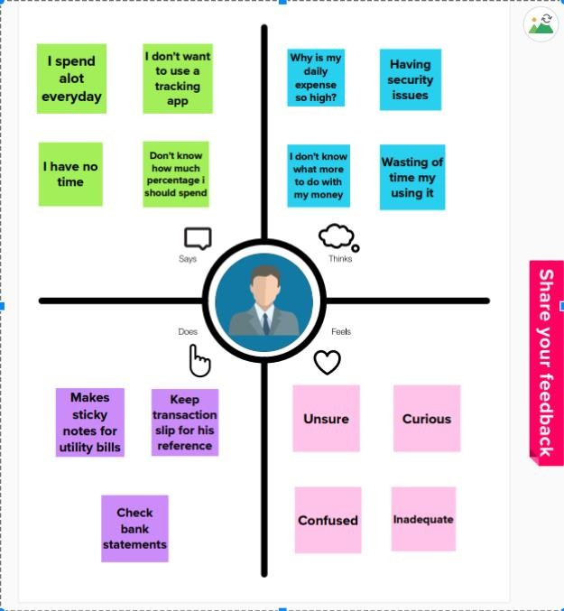

# IDEA ON & BRAINSTORMING

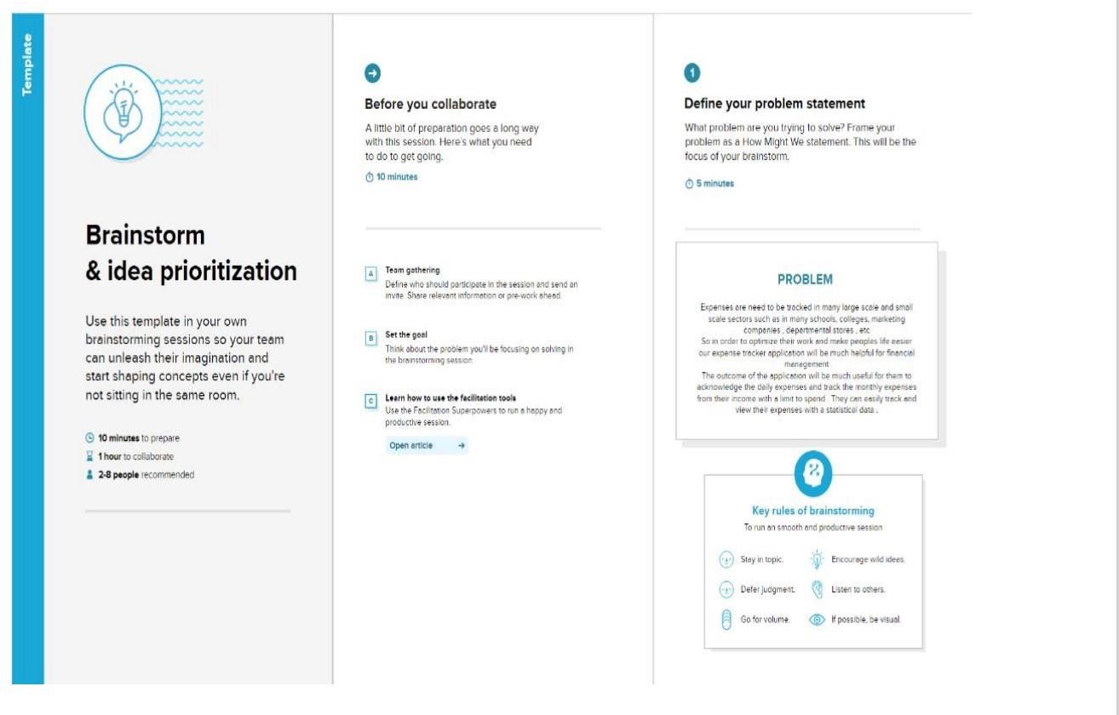Step-1: Team Gathering, Collaboration and Select the Problem Statement

Step-2: Brainstorm, Idea listening and Grouping

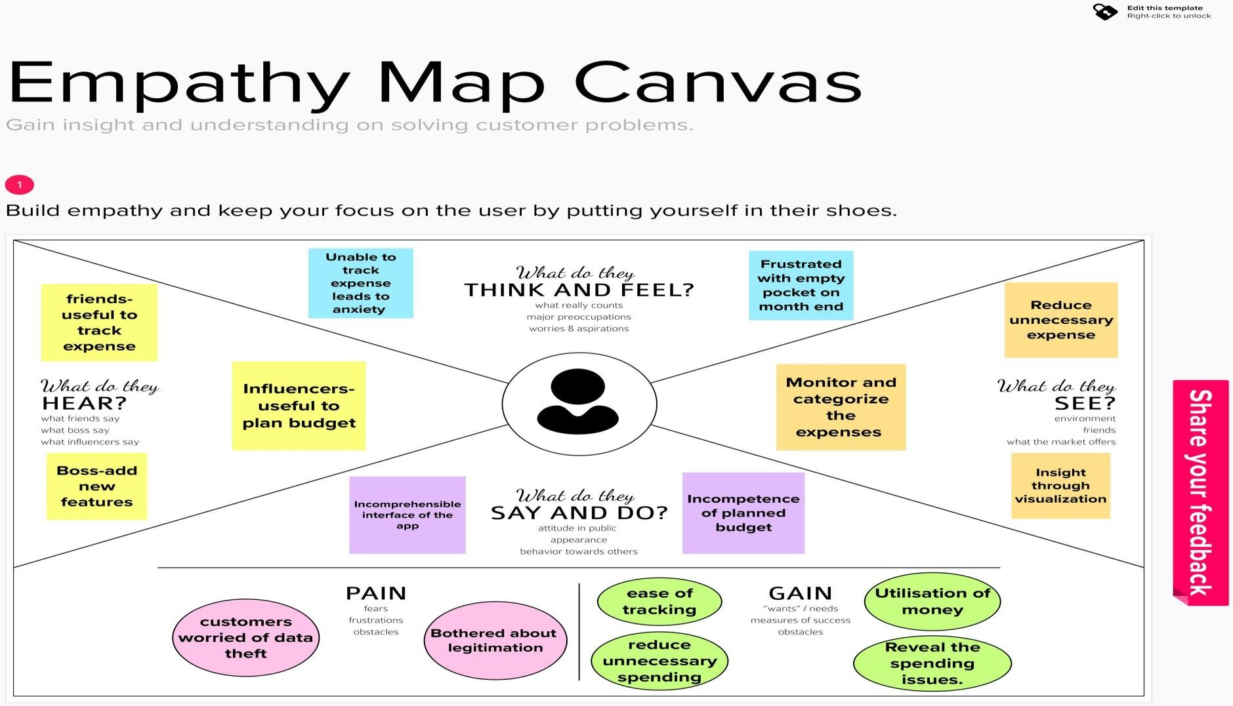

Step-3: Idea Prioritization

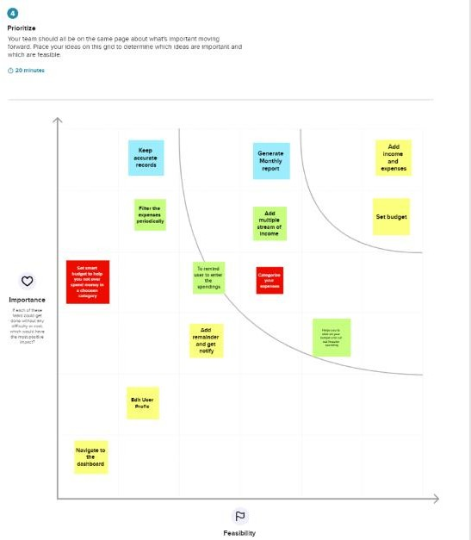

# PROPOSED SOLUTION

|  |  |  |
| --- | --- | --- |
| **S.NO.** | **Parameter** | **Description** |
| **1.** | Problem Statement | In paper-based expense tracker system it is difficult to track our monthly expenses manually. In paper-based expense tracker system it is difficult to track our monthly expenses manually. The paper-based expense records may get lost in case of fire accidents, flood etc. |
| **2.** | Scalability of the Solution | This application can handle large number of users and data with high performance and security. This application can adapt for both large-scale and small- scale purposes. Easily available in all kinds of devices. |
| **3.** | Idea / Solution description | Daily expense management system which is specially designed for non-salaried and salaried personnel for keeping track of their daily expenditure with easy and effective way through computerized system which tends to eliminate manual paper works. Personal finance applications will ask users to add their expenses and based on their expenses wallet balance will be updated which will be visible to the user. They have an option to set a limit for the amount to be used for that particular month if the limit is exceeded the user will be notified with an email alert. |
| **4.** | Novelty / Uniqueness | The user gets notified when their expense exceeds the limit and also it reminds the user when they forgot to make entry. Tracking expenses through SMS. Data analytics on expenses. Future expense prediction |

|  |  |  |
| --- | --- | --- |
|  |  |  |
| **5.** | Social Impact / Customer  Satisfaction | The application should be able to generate reports of their spending and notify users if  they have exceeded their budget. It is designed to be dynamic to produce the prediction. It also provides users’ personal information, their income as well as their expenses. This application can create awareness among common people about finance and stuffs. This application also helps user to be financially responsible. It Reduces time rather than entering details manually. |
| **6.** | Business Model (Revenue  Model) | This Application is provided for free of cost. But It will have some advertisement. In  premium version there is no advertisement and contains some additional features. |

* 1. **PROBLEM SOLUTION FIT**

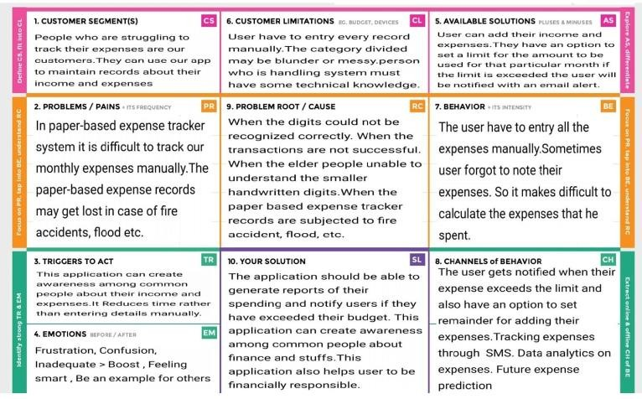

# REQUIREMENT ANALYSIS

* 1. **FUNCTIONAL REQUIREMENT**

|  |  |  |
| --- | --- | --- |
| **FR**  **No.** | **Functional Requirement**  **(Epic)** | **Sub Requirement(Story / Sub- Task)** |
| **FR- 1** | User Registration | Form for collecting details |
| **FR- 2** | Login | Enter username and password |
| **FR- 3** | Calendar | Personal expense tracker application must allo w user to add the data to their expenses. |
| **FR- 4** | Expense Tracker | This application should graphically represent the expense in the form of report. |
| **FR- 5** | Report generation | Graphical representation of report must be generated. |
| **FR- 6** | Category | This application shall allow users to add ca tegories of their expenses. |

# NON-FUNCTIONAL REQUIREMENTS

|  |  |  |
| --- | --- | --- |
| **FR**  **No.** | **NonFunctional Require**  **ment** | **Description** |
| **NFR-**  **1** | Usability | Helps to keep an accurate record of your  income and expenses. |
| **NFR-**  **2** | Security | Budget tracking apps are considered very sa  fe from those who commit cyber crimes. |
| **NFR- 3** | Reliability | Each data record is stored on a well built efficient database schema. There is no risk of data  loss. |
| **NFR- 4** | Performance | The types of expense are categories along with an  option. Throughput of the system is increase d due to light weight database support. |
| **NFR- 5** | Availability | The application must have a 100% up-time. |
| **NFR- 6** | Scalability | The ability to appropriately handle increasin  g demands. |

* 1. **PROJECT DESIGN**

# DATA FLOW DIAGRAMS

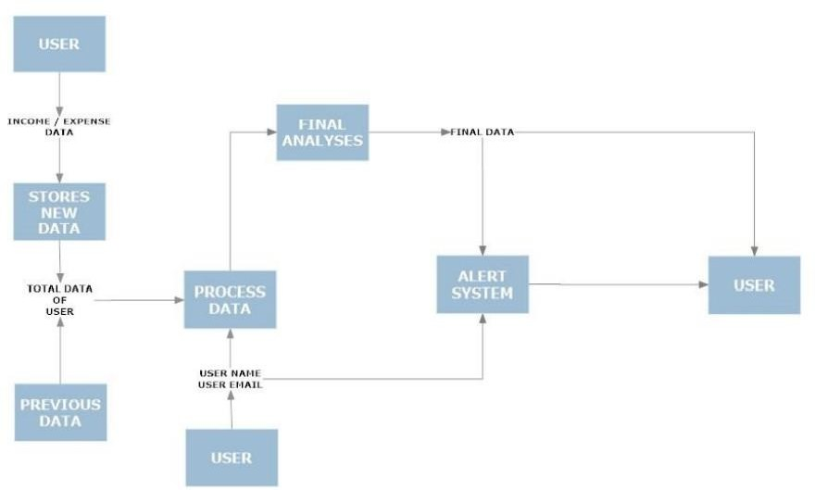

* 1. **SOLUTION & TECHNICAL ARCHITECTURE**

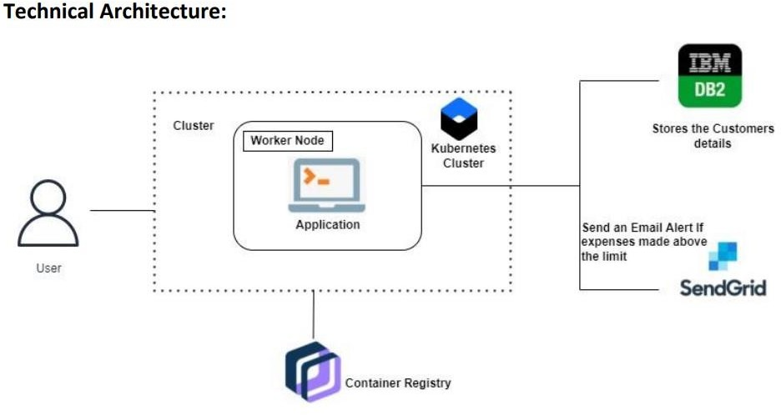

**Solution Architecture**

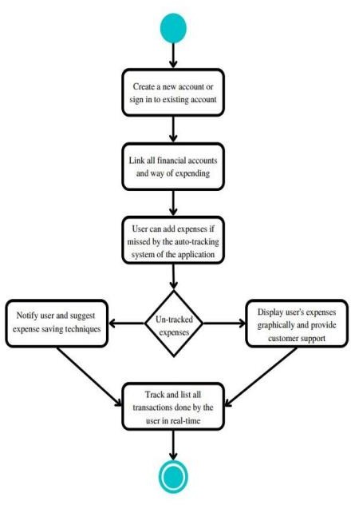

# USER STORIES

|  |  |  |  |  |  |
| --- | --- | --- | --- | --- | --- |
| **User Type** | **Functional Requirement (Epic)** | **User Story Number** | **User Story / Task** | **Acceptance criteria** | **Priority** |
| **Customer (Mobile user & web user )** | Registration | USN-1 | As a user, I can register for the application by entering my email, password,  and confirming my password. | I can access my account / dashboard | High |
|  |  | USN-2 | As a user, I will receive confirmation email once I have registered for the  application | I can receive confirmation email & click confirm | High |
|  |  | USN- 3 | As a user, I can register for the application through Facebook | I can register &  access the Dashboard with Facebook Login | Low |
|  | Login | USN -  4 | As a user, I can log into the application by entering email & password | I can access the application | High |
|  | Dashboard | USN -  5 | As a user I can enter my income and expenditure details. | I can view my daily expenses | High |
| **Customer Care Executive** |  | USN – 6 | As a customer care executive I can solve the log in issues and other issues  of the application. | I can provide support or solution at any time 24*7 | Medium |
| **Administrator** | Application | USN -  7 | As a administrator I can upgrade or update the application. | I can fix the bug which arises for the  customers and users of the application | Medium |

* 1. **PROJECT PLANNING & SCHEDULING**

# SPRINT PLANNING & ESTIMATION

|  |  |  |  |  |  |  |
| --- | --- | --- | --- | --- | --- | --- |
| **Sprint** | **Functional Require ment (Epic)** | **User Story Number** | **User Story / Task** | **Story Points** | **Priorit**  **y** | **Team Members** |
| **Sprint-1** | Registration | USN-1 | As a  user, I can register for the application by ente ring my email, password, and  confirming my password. | 8 | High | Praveen, Ajay |
| **Sprint-1** | Login | USN-2 | As a user, I can log into the application by entering email & password | 8 | High | Riyaz, Panneer |
| **Sprint-2** | Add Expense | USN-3 | As a user, I can add the day-to- day expense to the application | 5 | Medium | Praveen, Ajay |
| **Sprint-2** | Edit and Delete Expense | USN-4 | As a user, I can edit and delete the previously created expense | 5 | Medium | Riyaz, Panner |
| **Sprint-3** | Creating time based filters in history. | USN-5 | As a user, I can see the time based history of expenses. | 8 | High | Praveen, Ajay |
| **Sprint-3** | Integrating with pie- charts for analysis | USN-6 | As a user, I can view diagrammatic representation of expenses | 5 | Medium | Riyaz, Panneer |
| **Sprint-4** | Enabling limit feature | USN-7 | As a user, I can set monthly limit to expenses | 5 | Medium | Praveen, Ajay |
| **Sprint-4** | Sending Email Alerts | USN-8 | As a user, I will receive a mail if I cross a limit | 8 | High | Riyaz, Panneer |

* 1. **SPRINT DELIVERY SCHEDULE**

|  |  |  |  |  |  |  |
| --- | --- | --- | --- | --- | --- | --- |
|  | **Total**  **Story P oints** | **Durat ion** | **Sprint Start Date** | **Sprint End Date (**  **Planned)** | **Story Points Completed (as o n Planned End Date)** | **Sprint Release D ate (Actual)** |
| **Sprint** |  |  |  |
| **Sprint-1** | 20 | 6  Days | 23 Oct 2022 | 12 Oct 2022 | 20 | 13 Oct 2022 |
| **Sprint-2** | 20 | 6  Days | 30 Oct 2022 | 13 Nov  2022 | 20 | 15 Nov 2022 |

|  |  |  |  |  |  |  |
| --- | --- | --- | --- | --- | --- | --- |
| **Sprint-3** | 20 | 6  Days | 06 Nov 2022 | 15 Nov  2022 | 20 | 17 Nov 2022 |
| **Sprint-4** | 20 | 6  Days | 13 Nov 2022 | 18 Nov  2022 | 20 | 19 Nov 2022 |

**Velocity**

We have a 6-day sprint duration, and the velocity of the team is 20 (points per sprint). Calculating the team’s average velocity (AV) per iterationunit (story points per day)

**𝐴𝑉 = sprint duration / velocity = 20/6 = 3.33**

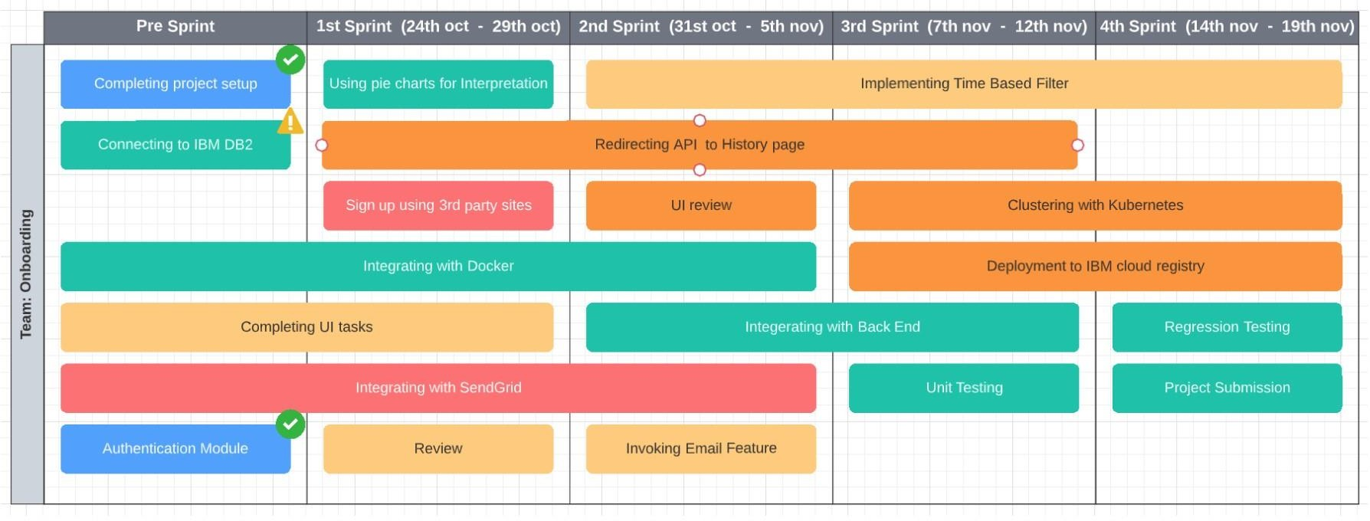

# Burn down Chart:

A burn down chart is a graphical representation of work left to do versus time. It is often used in agile software development methodologies such as Scrum. However, burn down chart s can be applied to any project containing measurable progress over time.

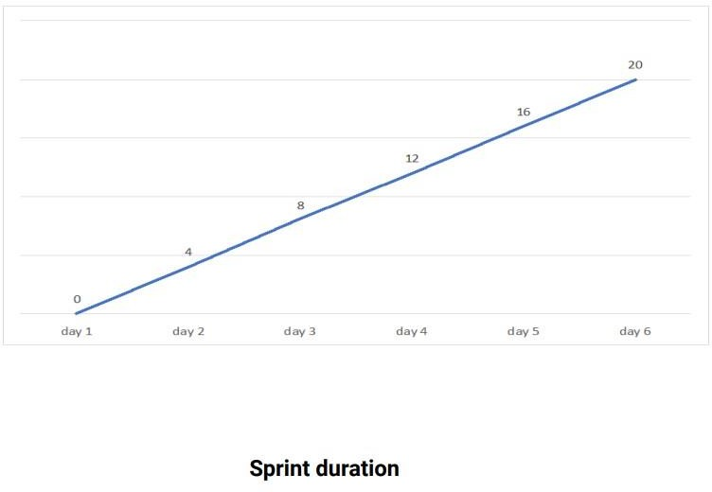

# REPORTS FROM JIRA

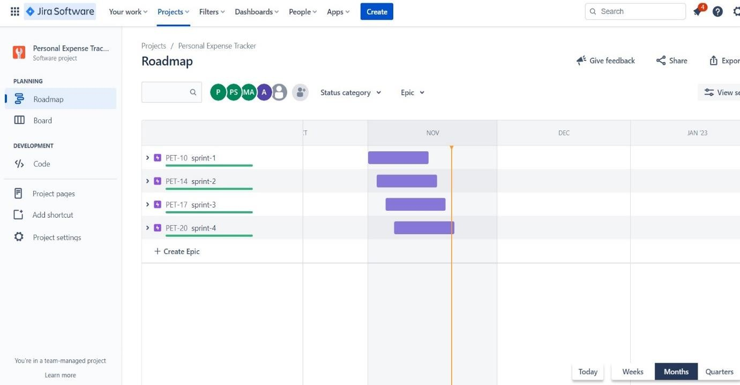

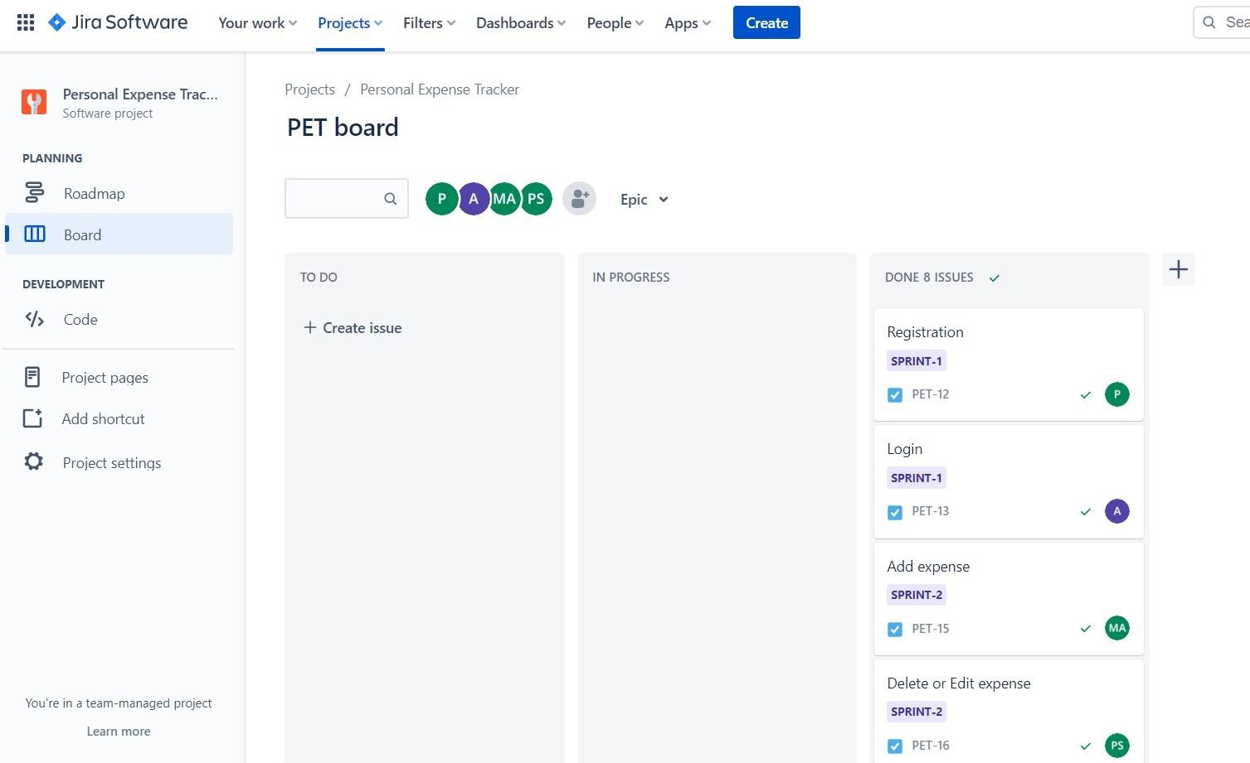

* 1. **CODING & SOLUTIONING (Explain the features added in the project along with code)**

# FEATURE 1

We have added the data visualization methods for expenditure. The pie chart have been used to represent the monthly expenses. The pie chart is a pictorial representation of data that makes it possible to visualize the relationships between the parts and the whole of a variable. For example, it is possible to understand the industry count or percentage of a variable level from the division by areas or sectors. The recommended use for pie charts is two-dimensional, as three-dimensional use can be confusing.

The dimensions form sectors of the measurement values; they can have one or two sizes and up to two measures. The first dimension is used to define the angle of each sector that makes up the chart and the second dimension optionally determines the radius of each sector. Additionally, these plots are useful for comparing data over a fixed period since they do not show changes over time. Therefore, their use should be considered if:

* + - You are looking to categorize and compare a set of data.
    - You only have positive values.
    - You have less than seven categories since a larger number can make it difficult to perceive each segment.

## CODE:

Signup.html

<html>

<head>

<meta charset="utf-8">

<title>Sign-up</title>

<link href="..\static\css\signup.css" rel="stylesheet">

<script src="https://kit.fontawesome.com/a81368914c.js"></script>

<link rel="stylesheet"

href="https://maxcdn.bootstrapcdn.com/bootstrap/4.0.0/css/bootstrap.min.css" integrity="sha384- Gn5384xqQ1aoWXA+058RXPxPg6fy4IWvTNh0E263XmFcJlSAwiGgFAW/dAiS6JXm" crossorigin="anonymous">

</head>

<body>

<! container >

<div class="container" >

<!--sign-up-box-container--->

<div class="sign-up">

<div id="png"><a href="/" title="HOME"><img style="width:55px; height:55px ; " src="..\static\images\home-page.png"></a></div>

<!--heading-->

<form action="/register" method="post">

<div class="msg">{{ msg }}</div>

<h1 class="heading">Hello,Friend</h1>

<!--name-box-->

<div class="text">

<img height="20px" src="..\static\images\user.png" />

<input placeholder="Name" type="text" name="username"/>

</div>

<!--Email-box-->

<div class="text">

<img height="12px" src="..\static\images/email.png" />

<input placeholder=" [Example@gmail.com](mailto:Example@gmail.com)" type="email" name="email"" />

</div>

<!--Password-box-->

<div class="text">

<img height="20px" src="..\static\images\password.png" />

<input placeholder=" Password" type="password" name="password"/>

</div>

<div class="or"><b>OR</b></div>

<div class="s1"><p><b>Sign-up with</b></p></div>

<div>

<ul>

<li><a href="#"><i class="fab fa-facebook" aria-hidden="true"></i></a></li>

<li><a href="#"><i class="fab fa-twitter" aria-hidden="true"></i></a></li>

<li><a href="#"><i class="fab fa-google" aria-hidden="true"></i></a></li>

<li><a href="#"><i class="fab fa-linkedin" aria-hidden="true"></i></a></li>

<li><a href="#"><i class="fab fa-instagram" aria-hidden="true"></i></a></li>

</ul>

</div>

<!--trems-->

<div class="trems">

<input class="check" type="checkbox" required/>

<p class="conditions">I read and agree to <a href="#">Trems &amp; Conditions</a></p>

</div>

<!--button-->

<div class="toop">

<button type="submit" class="btn btn-primary" >CREATE ACCOUNT</button> </div>

</form>

<!--sign-in-->

<div class="t"><p class="conditions" id="p3">Already have an account <a href="/signin">Sign in</a></p> </div></div>

</div>

<!--text-container-->

<div class="text-container">

<h1 style="color: #2d2c2c;font-family:cursive;">Glad to see you</h1>

<div class="diag"><img class="fig1" width="100%" height="105%" src="..\static\images\Inkeddia_LI.jpg"</div>

<div class="para"> <b>Welcome</b>,Please Fill in the blanks for sign up</div>

</div>

</div>

</body>

</html>

## App.py

from flask import Flask, render_template, request, redirect, session # from flask_mysqldb import MySQL

# import MySQLdb.cursors import re

from flask_db2 import DB2 import ibm_db

import ibm_db_dbi

from sendemail import sendgridmail,sendmail

# from gevent.pywsgi import WSGIServer import os

app = Flask( name )

app.secret_key = 'a' """

dsn_hostname = "ba99a9e6-d59e-4883-8fc0- d6a8c9f7a08f.c1ogj3sd0tgtu0lqde00.databases.appdomain.cloud" dsn_uid = "vmk08423"

dsn_pwd = "3KfJl6HGDtPdbIWy" dsn_driver = "{IBM DB2 ODBC DRIVER}" dsn_database = "bludb"

dsn_port = "31321" dsn_protocol = "tcpip"

dsn = (

"DRIVER={0};"

"DATABASE={1};"

"HOSTNAME={2};"

"PORT={3};"

"PROTOCOL={4};"

"UID={5};"

"PWD={6};"

).format(dsn_driver, dsn_database, dsn_hostname, dsn_port, dsn_protocol, dsn_uid, dsn_pwd)

"""

# app.config['DB2_DRIVER'] = '{IBM DB2 ODBC DRIVER}'

app.config['database'] = 'bludb' app.config['hostname'] = 'ba99a9e6-d59e-4883-8fc0-

d6a8c9f7a08f.c1ogj3sd0tgtu0lqde00.databases.appdomain.cloud' app.config['port'] = '31321'

app.config['protocol'] = 'tcpip' app.config['uid'] = 'vmk084230' app.config['pwd'] = '3KfJl6HGDtPdbIWy' app.config['security'] = 'SSL'

try:

mysql = DB2(app) conn_str='database=bludb;hostname=ba99a9e6-d59e-4883-8fc0-

d6a8c9f7a08f.c1ogj3sd0tgtu0lqde00.databases.appdomain.cloud;port=31321;prot ocol=tcpip;\

uid=vmk08423;pwd=3KfJl6HGDtPdbIWy;security=SSL' ibm_db_conn = ibm_db.connect(conn_str,'','')

print("Database connected without any error !!") except:

print("IBM DB Connection error : " + DB2.conn_errormsg())

#HOME--PAGE

@app.route("/home") def home():

return render_template("homepage.html")

@app.route("/") def add():

return render_template("home.html")

# FEATURE 2

Email notiﬁcations will be sent to the users once they cross the expenditure limit through send grid mail system. Most notiﬁcations are transactional, meaning a recipient’s action or account activity triggers them. But some notiﬁcations are marketing related, encouraging the recipient to take a speciﬁc action. Ecommerce product notiﬁcations inform recipients about new products or discounts. Plus, unlike general marketing emails, these are highly personalized and focus on a singleproduct. For example, if a customer views an item on your website and that item goes on sale, you

can send the customer a notiﬁcation to let them know this is the best time to buy. Users can also opt into receiving notiﬁcations when an out-of- stock item is back in stock.

Notiﬁcation emails tend to perform well because the content is highly relevant to the recipient. But the only way for the recipient toknow this is if you state the content clearly in the subject line.

For example, the subject line “New Sign-in to Your Account” getsstraight to the point, letting the user know why you sent this notiﬁcation.

Sendemail.py

def sendgridmail(user,TEXT):

# from_email = Email("[mohamedriyazafzal@gmail.com](mailto:mohamedriyazafzal@gmail.com)") from_email = Email("[tproduct8080@gmail.com](mailto:tproduct8080@gmail.com)") to_email = To(user)

subject = "Sending with SendGrid is Fun" content = Content("text/plain",TEXT)

mail = Mail(from_email, to_email, subject, content)

# Get a JSON-ready representation of the Mail object mail_json = mail.get()

# Send an HTTP POST request to /mail/send

response = sg.client.mail.send.post(request_body=mail_json) print(response.status_code)

print(response.headers)

# 7.3 DATABASE SCHEMA

## Tables

### REGISTER

id INT NOT NULL GENERATED ALWAYS AS IDENTITY, username VARCHAR(255) NOT NULL,

email VARCHAR(255) NOT NULL, password VARCHAR(255) NOT NULL

### EXPENSES

id INT NOT NULL GENERATED ALWAYS AS IDENTITY,

userid INT NOT NULL,

date TIMESTAMP NOT NULL,

expensename VARCHAR(255) NOT NULL, amount INT NOT NULL,

paymode VARCHAR(255) NOT NULL, category VARCHAR(255) NOT NULL

**LIMITS**

id INT NOT NULL GENERATED ALWAYS AS IDENTITY, userid VARCHAR(255) NOT NULL,

limitss VARCHAR(255) NOT NULL

# TESTING

* 1. **TEST CASES**

|  |  |  |  |
| --- | --- | --- | --- |
| TEST CASE ID | PURPOSE | **TEST CASES** | **RESULT** |
| TC1 | Authentication | Password with length less than 4 characters | Password cannot be less than 4 characters |
| TC2 | Authentication | User name with  length less than 2 characters | User name cannot be less than 2 characters |
| TC3 | Authentication | Valid user name with minimum2 characters | User name accepted |
| TC4 | Authentication | User name left blank | User name cannot be less than 2 characters |
| TC5 | Authentication | Password field left blank | Password cannot be empty |
| TC6 | Authentication | Minimum 4 characters valid password | Password accepted |
| TC7 | Authentication | Password and Confirm Password did not match | Please enter same password |
| TC8 | Authentication | Confirm Password field left blank | Please enter same password |

# USER ACCEPTANCE TESTING

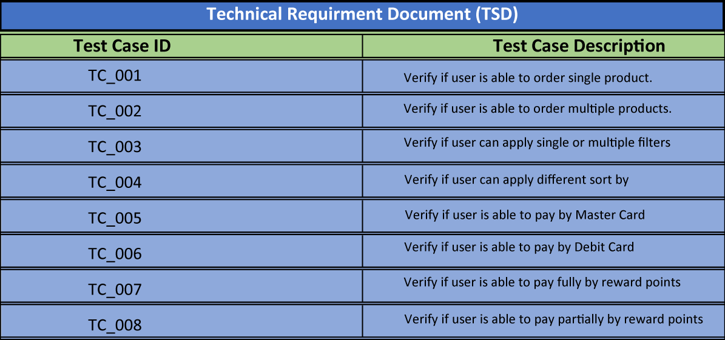

* 1. **RESULTS**

# 9.1 PERFORMANCE METRICS

* Tracking income and expenses: Monitoring the income and tracking all expenditures (through bank accounts, mobile wallets, and credit & debit cards).
* Transaction Receipts: Capture and organize your payment receipts to keep track of your expenditure.
* Organizing Taxes: Import your documents to the expense tracking app, and it will streamline your income and expenses under the appropriate tax categories.
* Payments & Invoices: Accept and pay from credit cards, debit cards, net banking, mobile wallets, and bank transfers, and track the status of your invoices and bills in the mobile app itself. Also, the tracking app sends reminders for payments and automatically matches the payments with invoices.
* Reports: The expense tracking app generates and sends reports to give a detailed insight about profits, losses, budgets, income, balance sheets, etc.,
* E-commerce integration: Integrate your expense tracking app with your eCommerce store and track your sales through payments received via multiple payment methods.
* Vendors and Contractors: Manage and track all the payments to the vendors and contractors added to the mobile app.
* Access control: Increase your team productivity by providing access control to particular users through custom permissions.
* Track Projects: Determine project profitability by tracking labor costs, payroll, expenses, etc., of your ongoing project.
* Inventory tracking: An expense tracking app can do it all. Right from tracking products or the cost of goods, sending alert notifications when the product is running out of stock or the product is not selling, to purchase orders.
* In-depth insights and analytics: Provides in-built tools to generate reports with easy-to- understand visuals and graphics to gain insights about the performance of your business.
* Recurrent Expenses: Rely on your budgeting app to track, streamline, and automate all the recurrent expenses and remind you on a timely basis.

# ADVANTAGES AND DISADVANTAGES

**ADVANTAGES:**

1. Improved visibility:

Most expense management software includes a dashboard that compiles employee expense data and presents it in an easy-to-understand visual format using charts and other graphics.

1. Security:

All the Data’s are stored in ibm cloud and db2 so all the data are maintained safely.

1. Month wise Comparison:

Using the Expense Manager, you can easily make month on month comparisons of earning, expenses and spending in a more organized manner.

1. Alert Mail:

User Receives the alert mail when they exceed the expense limit.

1. Automation:

All the calculations are automated. Graph are generated based on the expense made.

1. User Friendly:

Expenses can be added easily.

# DISADVANTAGE:

1. Requires Internet Connection:

This web application requires an active internet connection to access.

1. Cost:

Using cloud service need some investments. Every time we can’t access the cloud freely.

# CONCLUSION:

From this project, we are able to manage and keep tracking the daily expenses as well as income. While making this project, we gained a lot of experience of working as a team. We discovered various predicted and unpredicted problems and we enjoyed alot solving them as a team. We adopted things like video tutorials, text tutorials, internet and learning materials to make our project complete.

# FUTURE SCOPE:

* 1. User can able to upload the receipt of their expenses made. 2.Application will make suggestion to reduce unnecessary expense. 3.User get remainder in email to add their daily expense.

4.User can able to link bank accounts with our application

# APPENDIX:

**Github Source code link:**

<https://github.com/IBM-EPBL/IBM-Project-43162-1660713674>

# PROJECT DEMO LINK:

<https://vimeo.com/773031850> <https://youtu.be/LaRkQzHbuWM>